COLLABRY
Platform Usage Scenarios & Feature Walkthrough

A comprehensive guide to every implemented feature across
Brand, Influencer, and Admin personas.

Collabry Platform User Persona Use Case Diagram

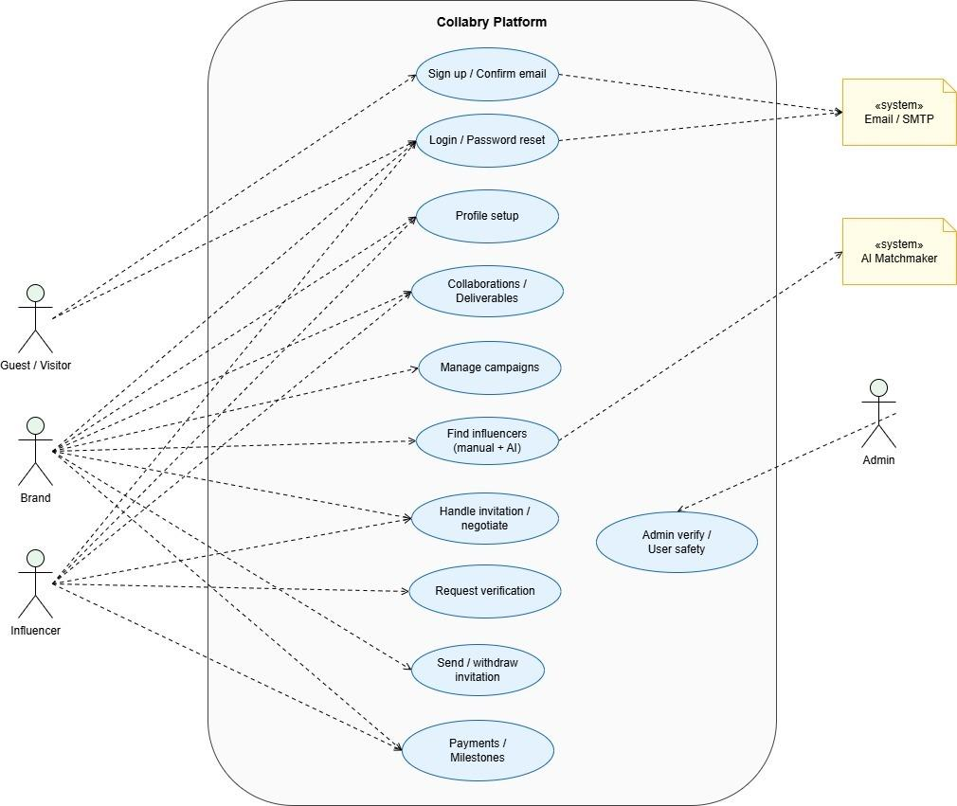

Description: The following diagram illustrates the Collabry Platform's functional boundary and the interactions between its four primary actors: Guests, Brands, Influencers, and Administrators. It maps out the complete service lifecycle from initial onboarding and AI-enhanced matchmaking to secure payment reconciliation and platform moderation. By integrating external SMTP Email and Groq AI Matchmaking systems, Collabry ensures a high-trust, automated environment where every user persona has a dedicated, secure workflow for achieving their marketing and growth objectives.

PHASE 1: ONBOARDING — COMMON FLOW

This phase captures how any new user enters the Collabry ecosystem, establishes their identity, selects their role (Brand or Influencer), and sets up their profile before accessing their personalized dashboard.

Scenario 1.1 — New User Registration & Profile Setup

Shot 1: The Collabry Landing Page & Global Navigation

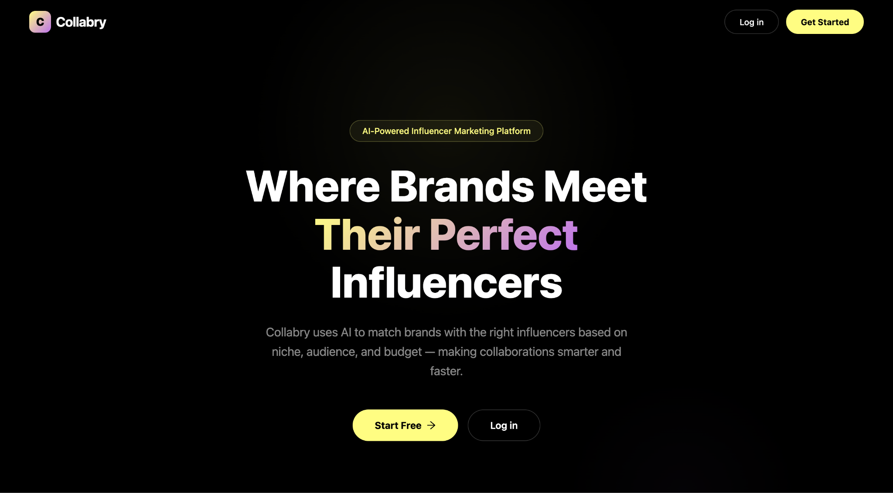

The user arrives at the primary Landing Page (/). A polished hero section and navigation bar welcome the visitor. A prominent 'Sign Up' button in both the hero section and the navbar initiates the registration journey, directing the user to /signup.

Shot 2: Multi-Persona Role Selection & Profile Setup

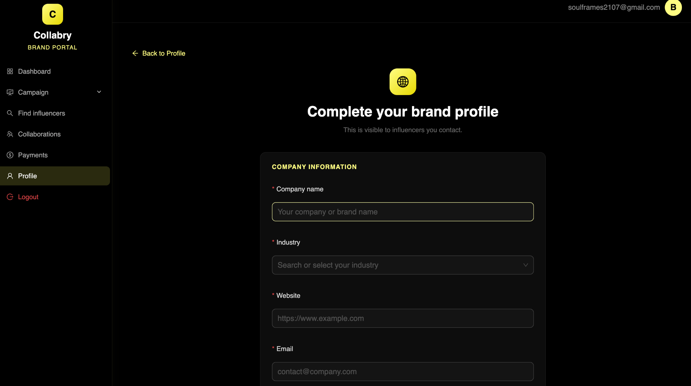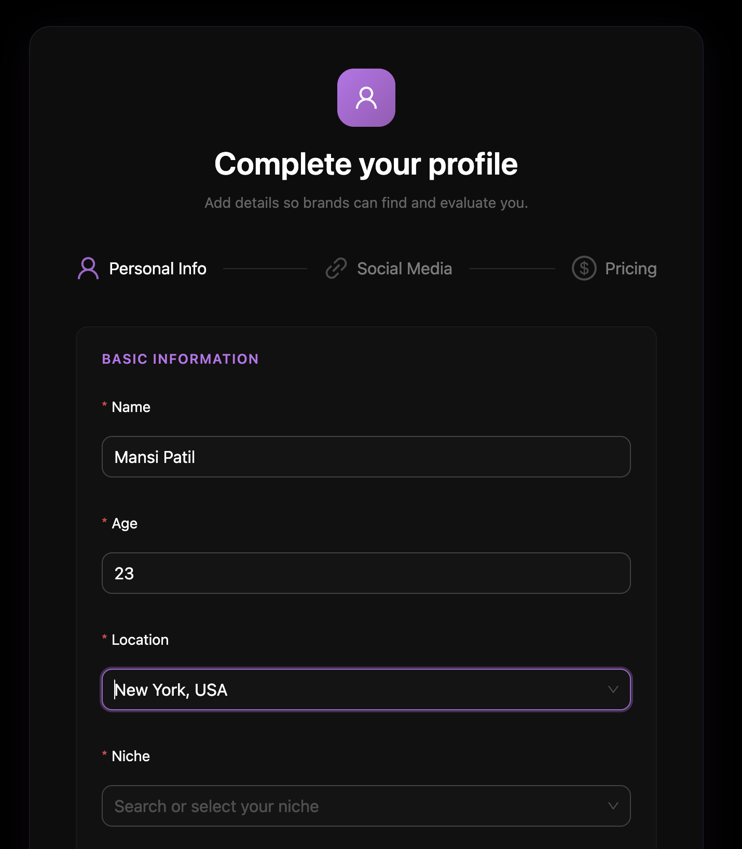
Upon first successful login, the user is redirected to /profile-setup. A clear role-selection toggle allows them to choose between 'Brand' and 'Influencer'. Selecting Brand reveals fields for Company Name, Industry Niche, Contact info, and Website. Selecting Influencer reveals fields for Name, Age, Location, Niche, Bio, Social Media handles, Follower Count, and standard Rate. On submission, the backend binds the selected role to the user's ID and routes them permanently to their specialized dashboard.

Scenario 1.2 — Account Recovery

Shot 3: Secure Account Recovery & Password Reset Interface

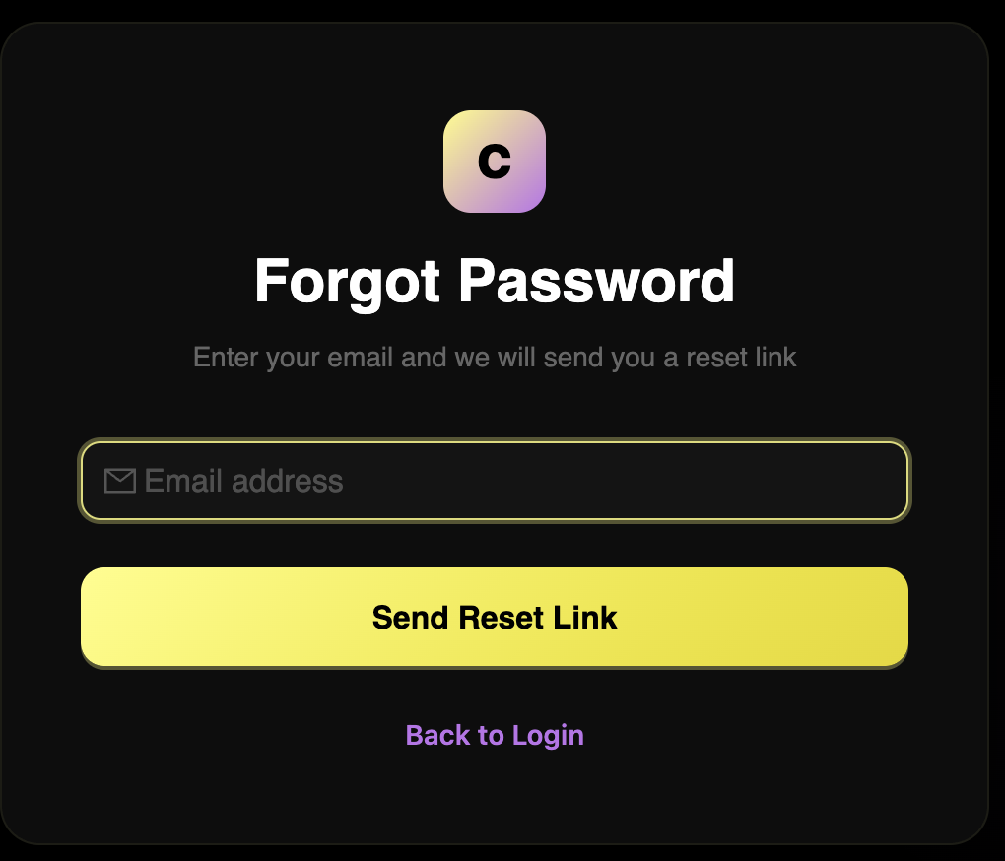

A registered user who has forgotten their password can recover their account via a secure token-based reset flow. After clicking 'Forgot Password' on /login, the user submits their email on /forgot-password. The system fires a mock email with a securely generated reset token. Clicking the link navigates the user to /reset-password?token=xxx, where they set a new password. The backend validates the token, hashes the new password, and safely redirects the user back to /login.

Scenario 1.3 — Requesting a verified Badge

Shot 4: Identity Verification Request (The "Blue Check" Submission)
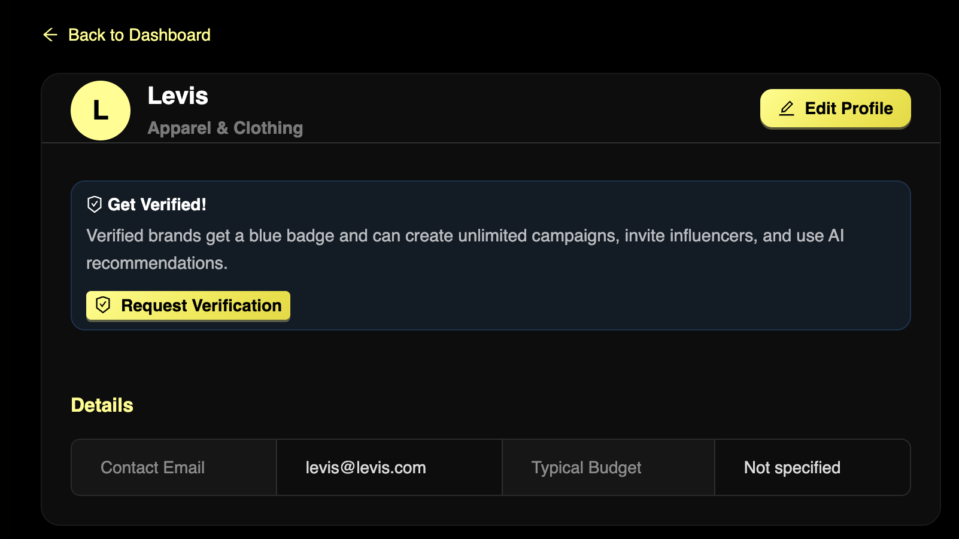
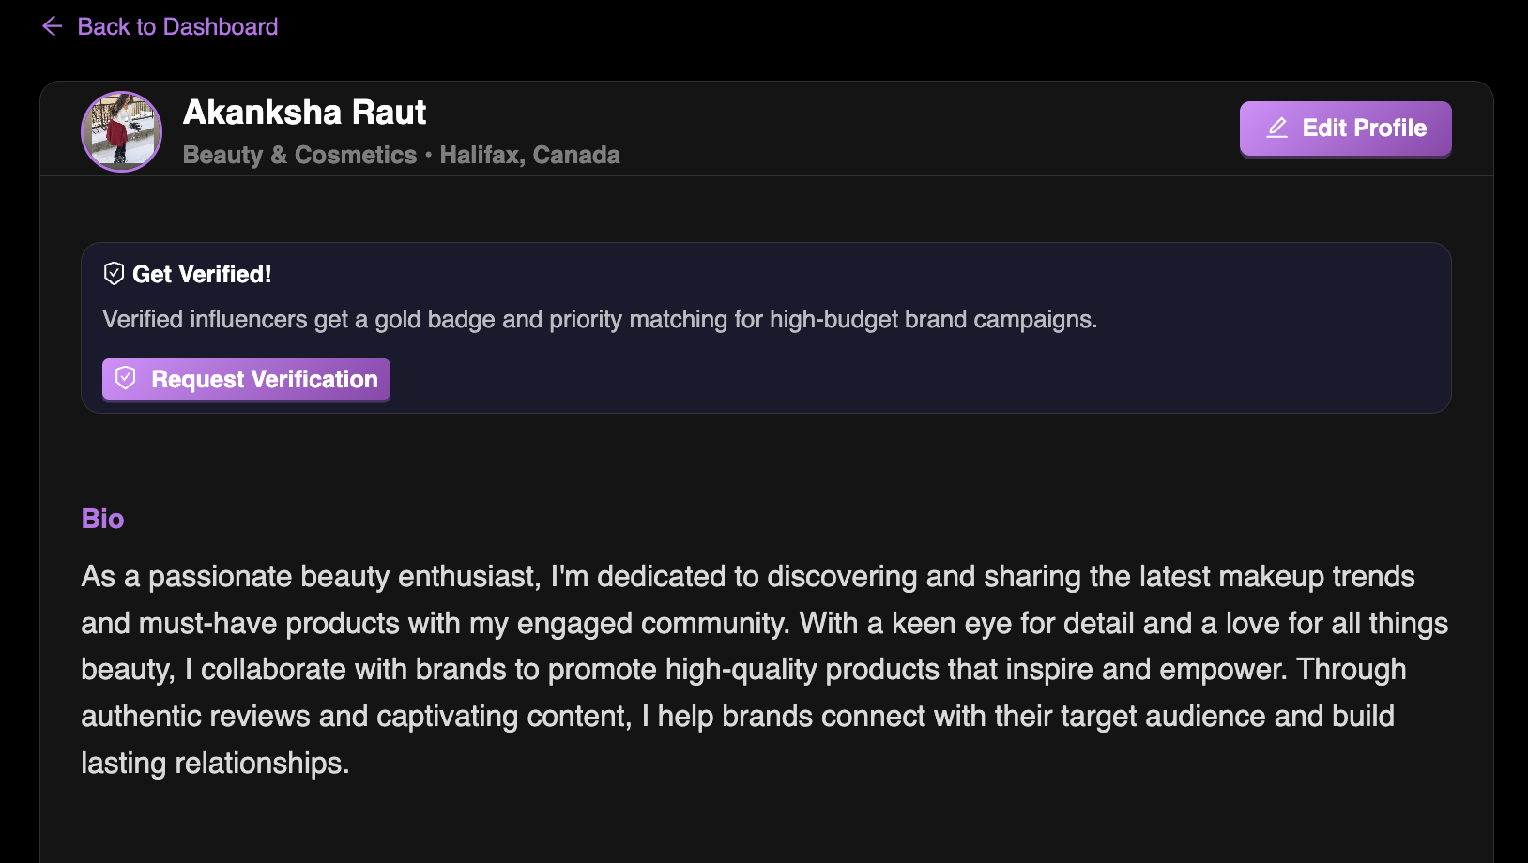
Any registered Brand or Influencer can request a platform verification badge. From their profile page they locate the 'Verification Status' section — initially showing 'Not Verified' — and click the 'Request Verification' button. The system submits the request to the Admin queue for manual review, and the UI immediately updates to display a blue 'PENDING' badge, informing the user that human oversight is underway.

PHASE 2: THE BRAND JOURNEY — CORE PRODUCT

This phase captures the complete lifecycle of a marketing professional managing influencer campaigns on Collabry - from creating and publishing campaigns, to finding and inviting influencers, to processing payments.

Scenario 2.1 — Creating a Campaign

Shot 5: Professional Campaign Creation Suite (Drafting your Launch)

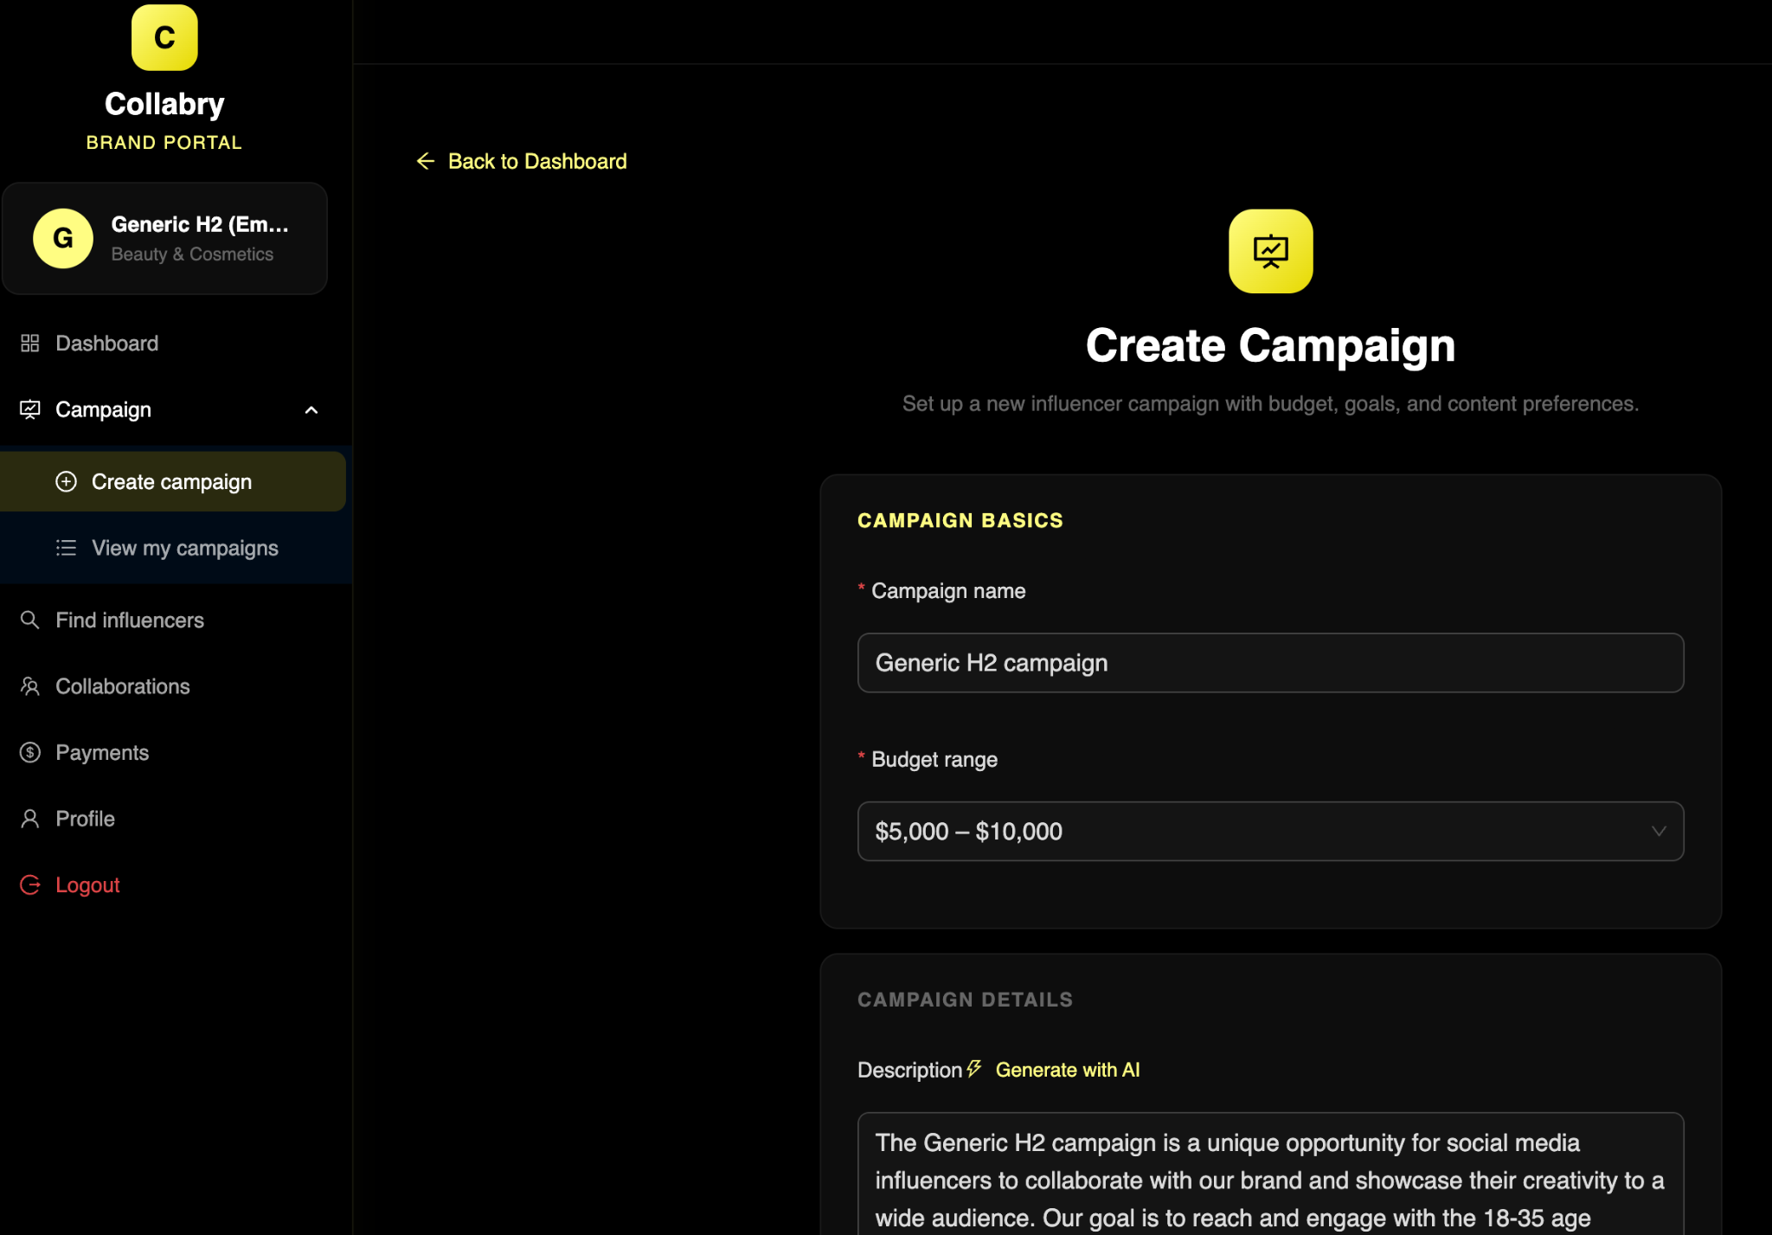
From /brand/dashboard the brand clicks 'Create Campaign', navigating to /brand/campaigns/create. The form accepts a Campaign Title (e.g., 'Summer Tech Launch'), Description, Budget (e.g., $5,000), Target Audience, and explicit Deliverable Requirements such as '1 Reel and 1 Story'. On submission, the system saves the campaign with a default status of DRAFT and redirects to the My Campaigns table, where the new draft is immediately visible.
1. AI Campaign Description Writer (Add to Phase 2)
Shot 6: AI-Powered Campaign Brief Generator
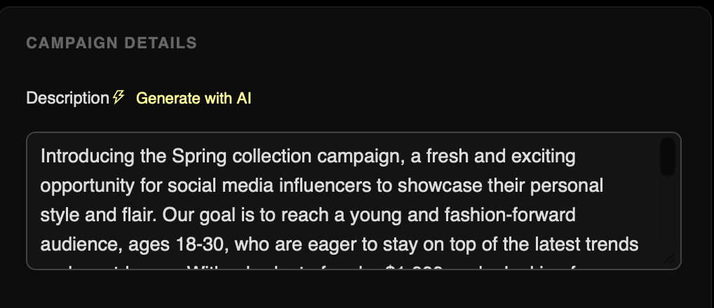
Within the campaign creation form (/brand/campaigns/create), the Brand can utilize the 'AI Enhance' button next to the description field. The Groq AI service processes the campaign’s core goals and target niche to automatically draft a professional and persuasive mission statement. This ensures that the campaign is marketable and clear to top-tier influencers from the very first draft.

Scenario 2.2 — Finding Influencers (Manual & AI)

Shot 6: Advanced Influencer Search, Sorting, and Filtering

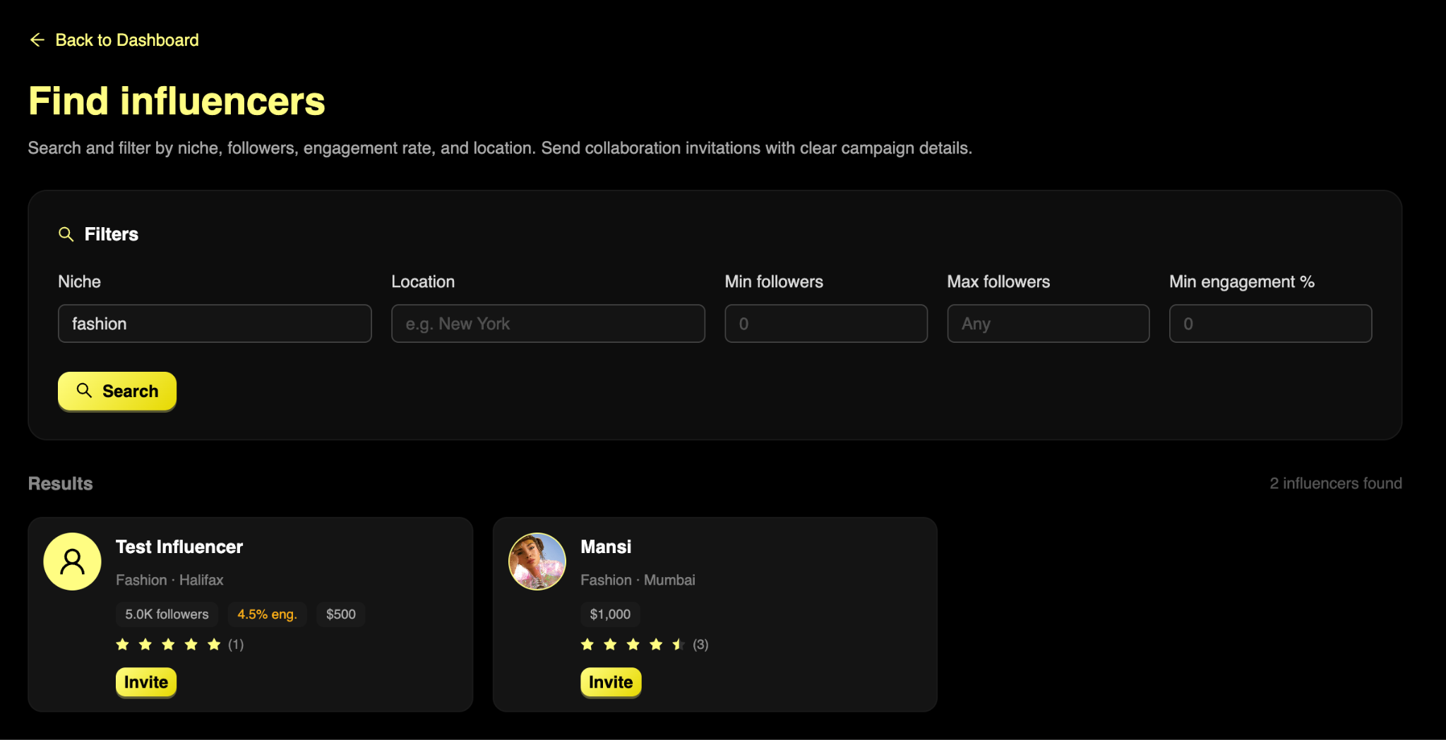
At /brand/influencers, the brand uses the search bar and filter dropdowns — Niche, Follower Count, and Age Range — to refine a responsive grid of registered influencers. Clicking 'View Profile' on any card opens the influencer's full public portfolio at /brand/influencers/{id}.

Shot 7: AI Smart Recommendation Drawer (Match Scores)
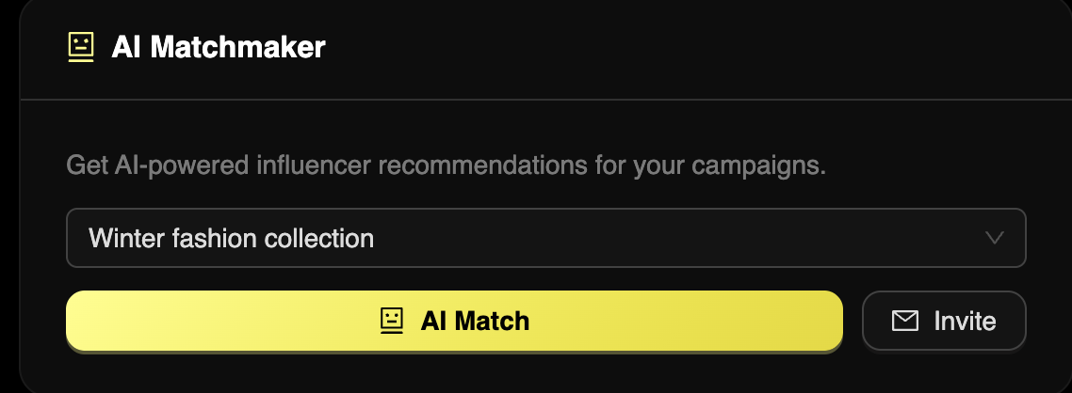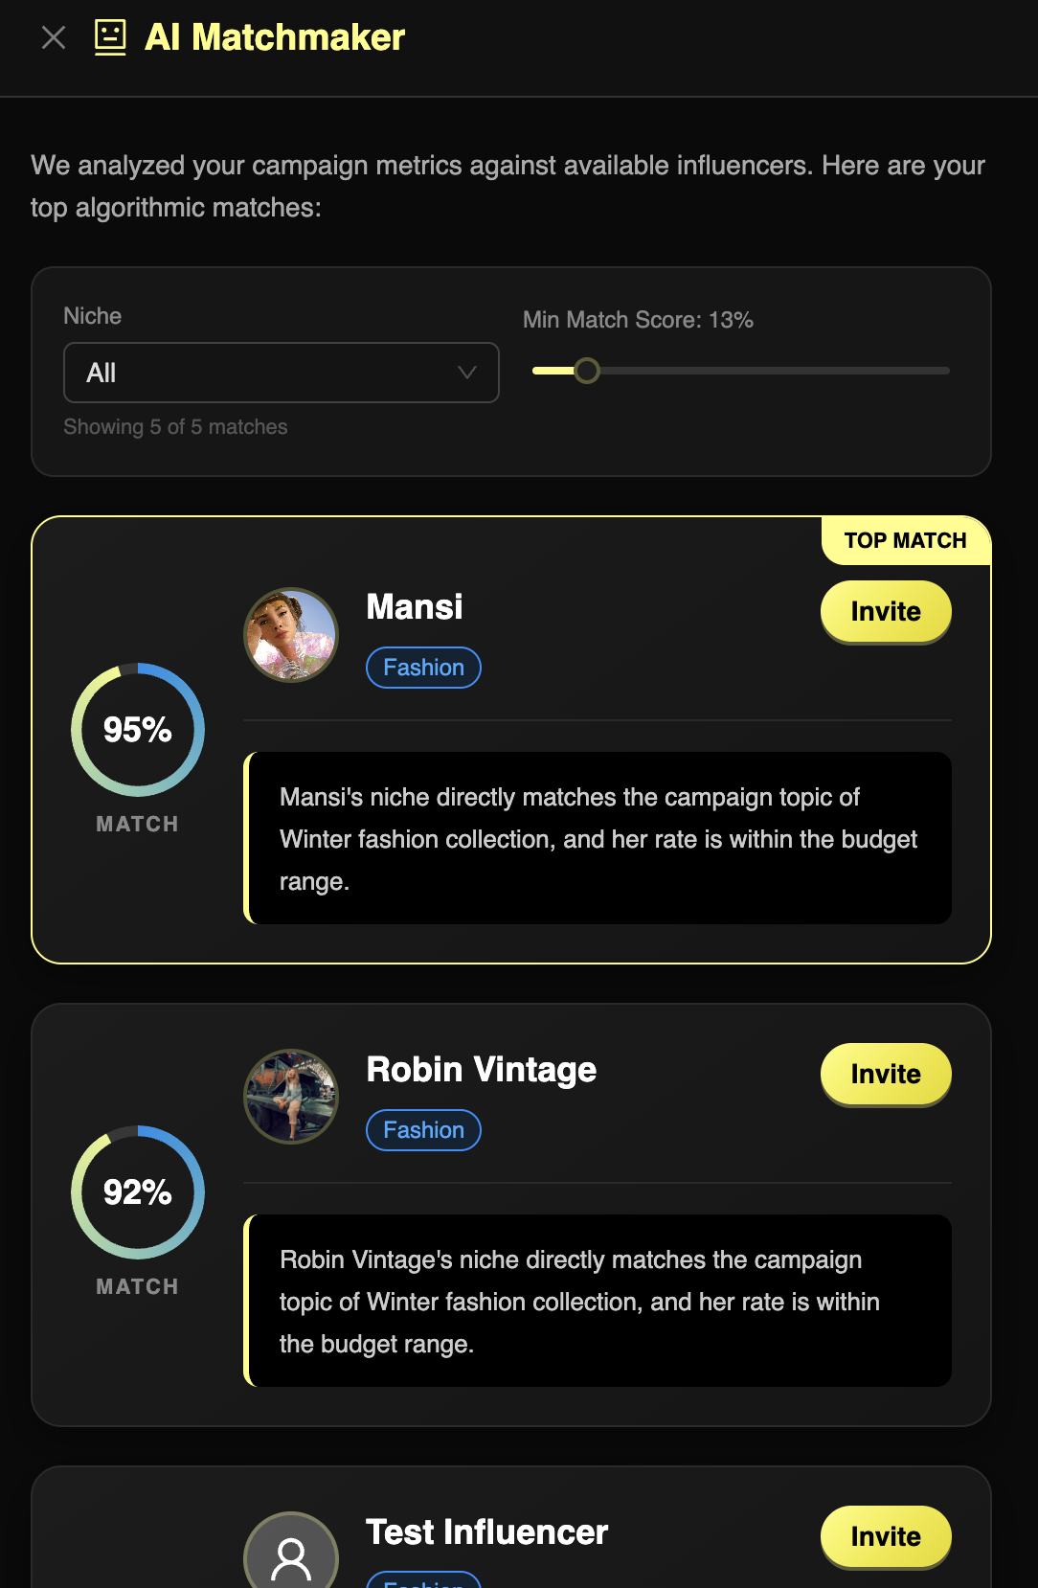
Clicking 'Get AI Recommendations' slides open a side drawer. The brand selects a DRAFT campaign; the backend queries the AI service, injecting the campaign's constraints and automatically scoring all registered influencers. The best-matched influencers are returned instantly inside the drawer, each annotated with a numerical Match Score to guide selection.
Scenario 2.3 — Sending & Withdrawing Invitations

Shot 8: Strategic Collaboration Invitation Modal (Defining Deliverables)

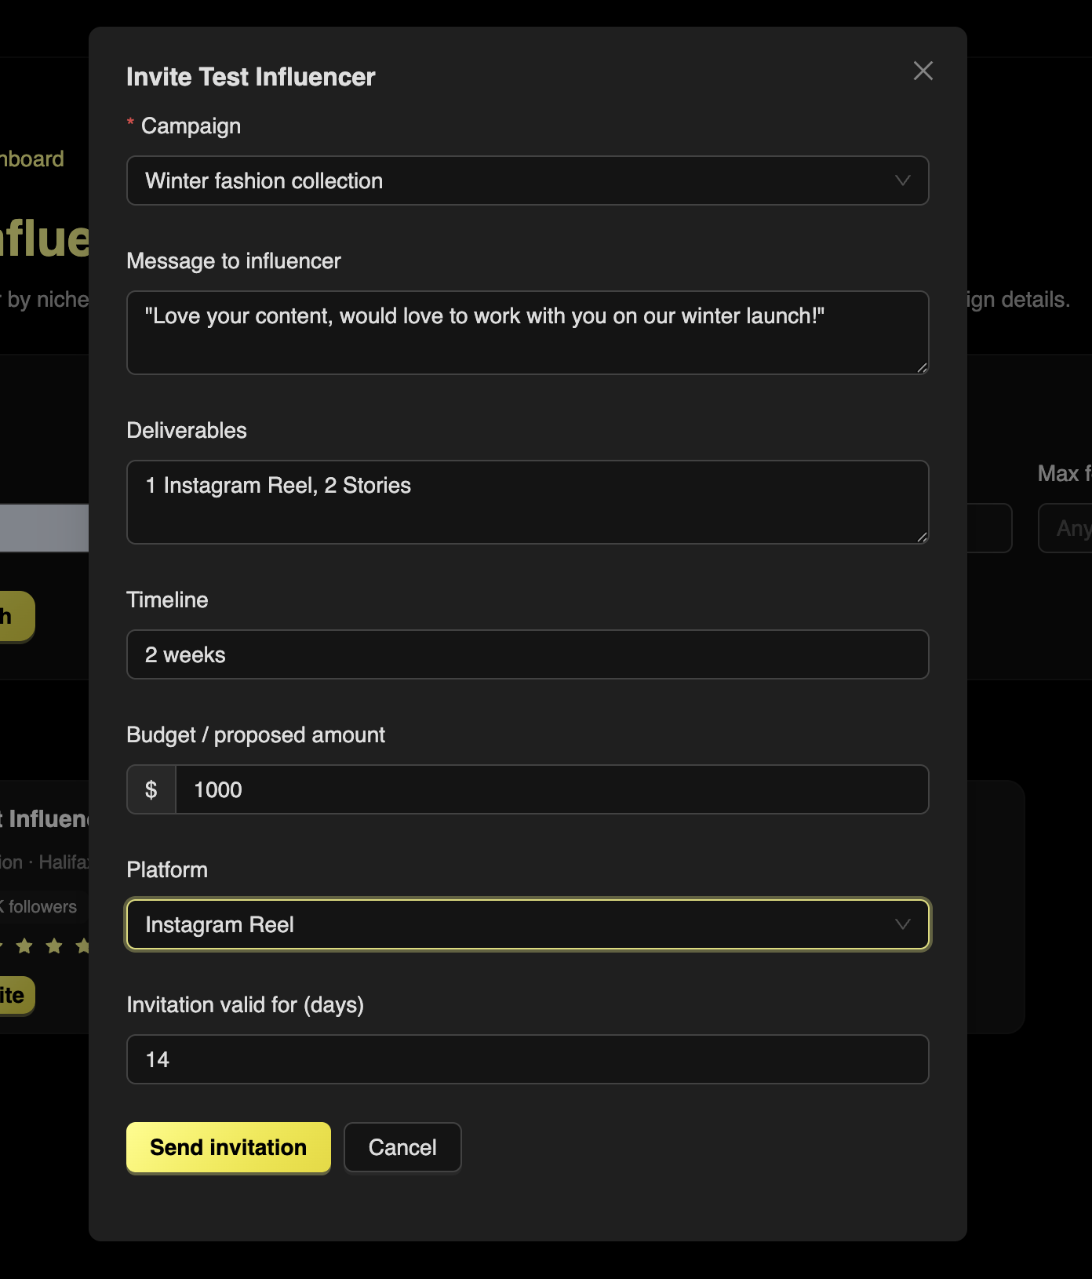
Having identified a target influencer, the brand clicks 'Invite', triggering a modal for finalizing contract terms. The brand selects the target Campaign, writes a personalized message, proposes a financial amount (e.g., $500), and checks required platforms such as Instagram or YouTube. Submitted invitations appear in the 'Sent Invitations' panel on /brand/dashboard with a status of PENDING. The red 'Withdraw' button removes a pending invitation via a clean cascading status update.

Scenario 2.4 — Campaign Lifecycle Management

Shot 9 — Campaign Dashboard (/brand/campaigns)

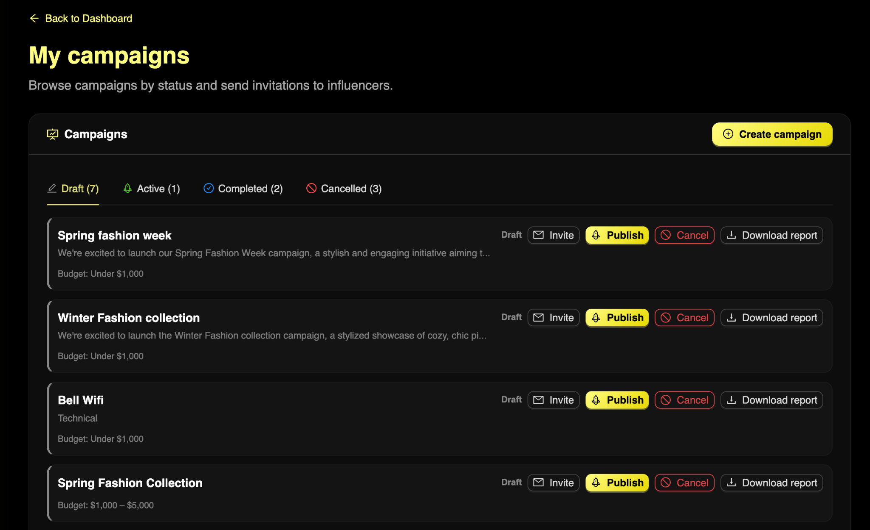
The /brand/campaigns view displays all campaigns with colorful status tags. A DRAFT campaign can be Published — validating ownership and transitioning the status to ACTIVE so influencers can officially accept invitations. At the end of a marketing season, clicking 'Complete' locks the campaign as COMPLETED. In an emergency, 'Cancel' locks the campaign as CANCELLED, preventing any further activity.

Scenario 2.5 — Processing Payments

At /brand/payments, the mocked PaymentService surfaces all outstanding invoices linked to ACCEPTED influencer collaborations. The brand can reconcile the timeline of released escrow funds versus pending payouts across all active marketing campaigns, providing full financial visibility.

Shot 10: Brand Financial Portal & Payout Tracking

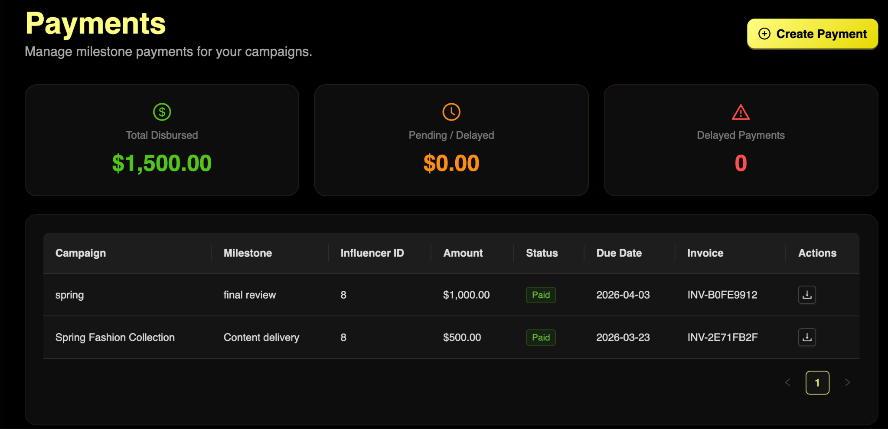

PHASE 3: THE INFLUENCER JOURNEY — CONTENT CREATOR LIFECYCLE

This phase captures the lifecycle of an autonomous content creator — from receiving invitations and negotiating rates, to fulfilling collaborations and tracking earnings.

Scenario 3.1 — Influencer Dashboard

Shot 11: Content Creator Central Dashboard (Task Overview)

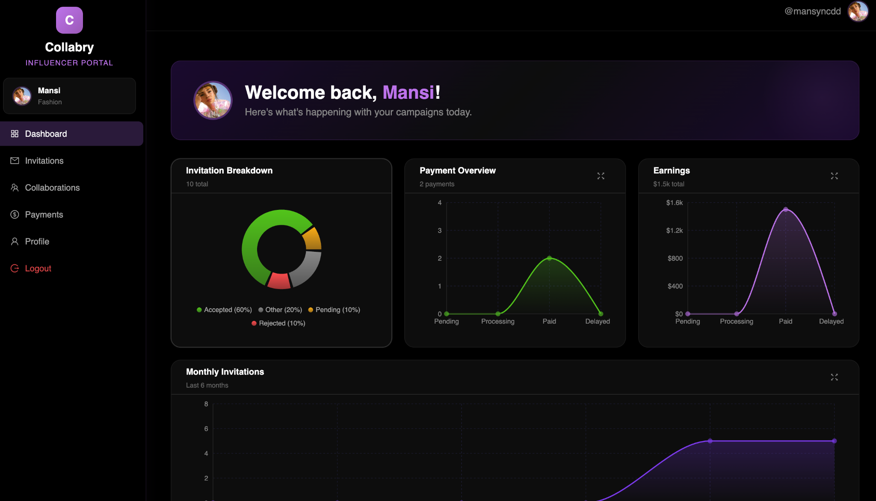
Upon login, the influencer lands on /influencer/dashboard. Quick statistics surface the count of Pending Invitations and Active Collaborations at a glance, allowing the creator to immediately prioritize their attention.

Scenario 3.2 — Handling Invitations (Accept / Reject / Negotiate)
Shot 12: Invitation Management & Inbox (Incoming Offers)

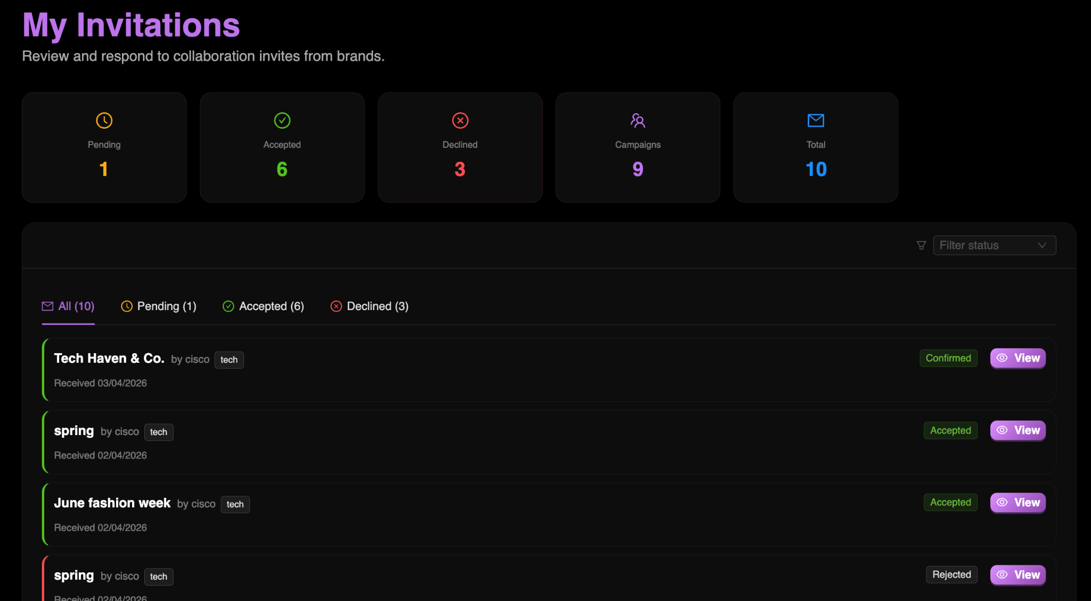

Shot 13 — Negotiation Screen (/influencer/invitations/{id})
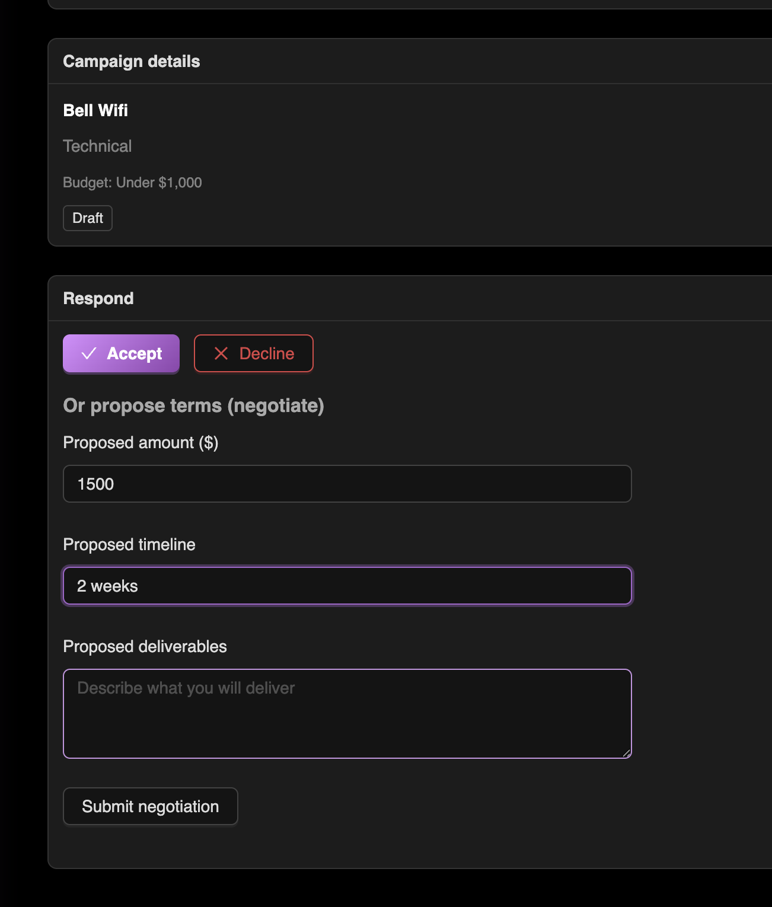
At /influencer/invitations, the influencer reviews all incoming offers. If the proposed rate is insufficient, clicking 'Negotiate' on /influencer/invitations/{id} opens a counter-offer form. The influencer proposes a revised amount (e.g., $850) and the system updates the invitation status to NEGOTIATING. Once the brand revises their offer and the influencer is satisfied, clicking the green 'Accept' button transitions the invite to ACCEPTED and instantly clones the data into a permanent Collaboration record.

Shot 13: Influencer Bio "Magic Wand" Enhancement
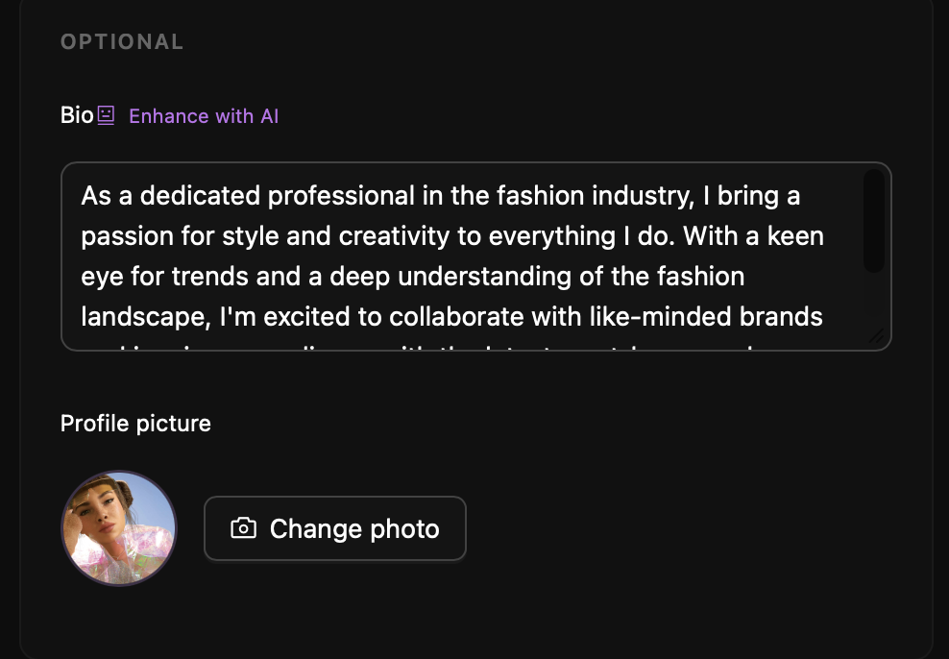
From the profile settings page, the Influencer can click the 'Enhance Bio' icon. By analyzing the creator’s social media handles and niche category, the AI generates a polished, high-converting professional biography. This feature helps creators define their "Brand Voice" instantly, making their profile significantly more attractive to potential brand partners.

Scenario 3.3 — Fulfilling Collaborations & Receiving Payouts

Shot 14: Active Collaboration Tracking & Deliverable Status
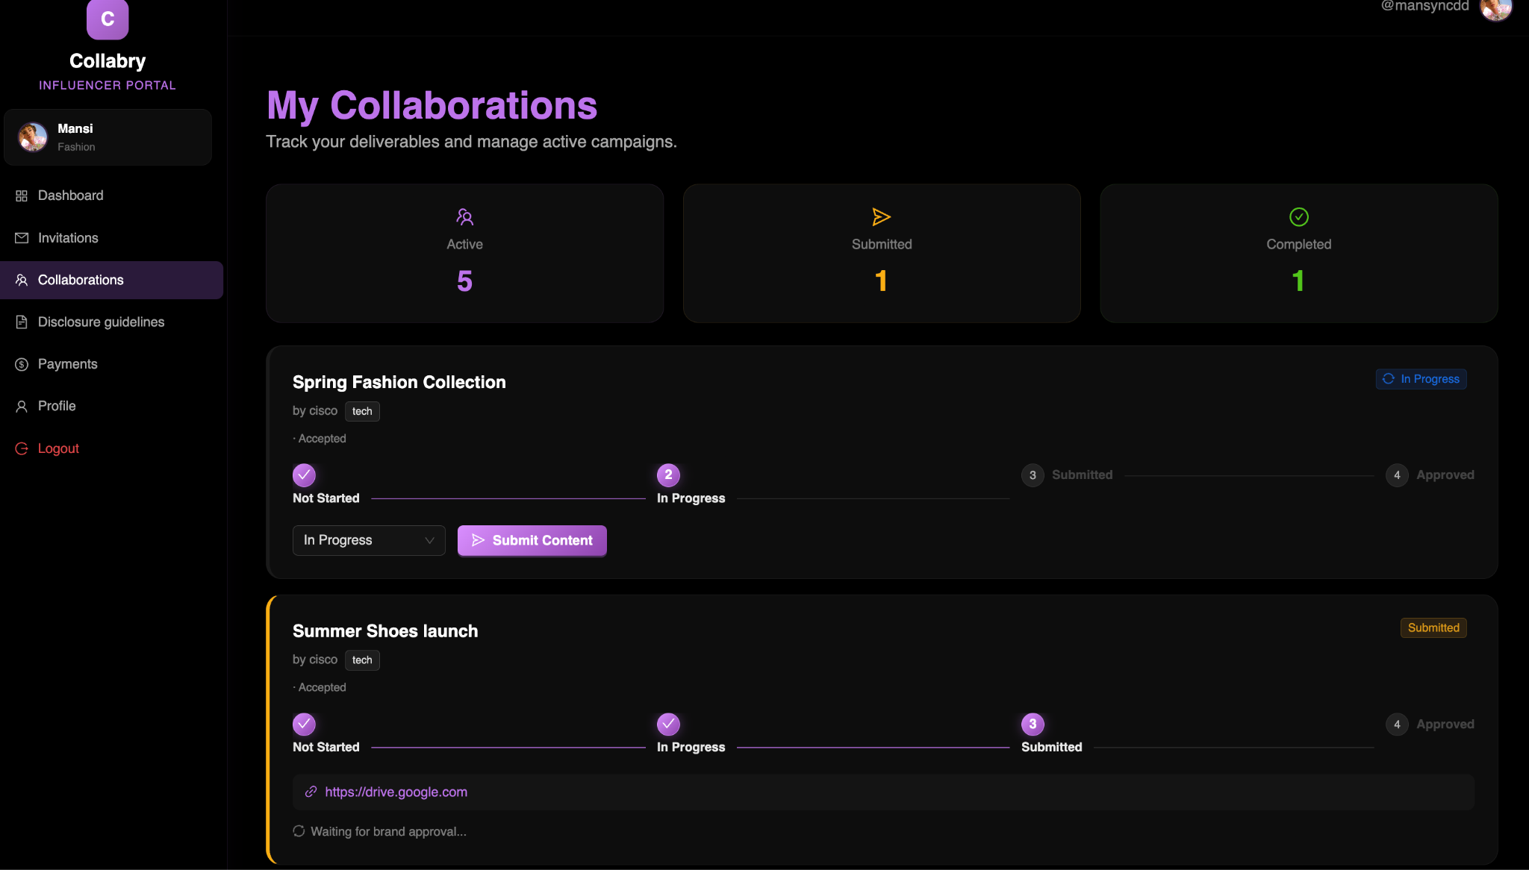

At /influencer/collaborations, the newly minted collaboration appears as ACTIVE. As the influencer posts content to the agreed platforms (e.g., Instagram), they can track deliverable completion within the platform. Background API social verification checks confirm activity. In conclusion, the influencer navigates to /influencer/payments to view a full historical ledger of earned funds and any pending escrow amounts awaiting release.

PHASE 4: ADMINISTRATIVE OVERSIGHT — PLATFORM MODERATION

This phase captures the platform moderation tools available to the Collabry Admin, ensuring the ecosystem remains safe, trustworthy, and accurately monitored.

Scenario 4.1 — Platform Monitoring & Enforcement

Shot 15 — Admin Dashboard (/admin/dashboard)
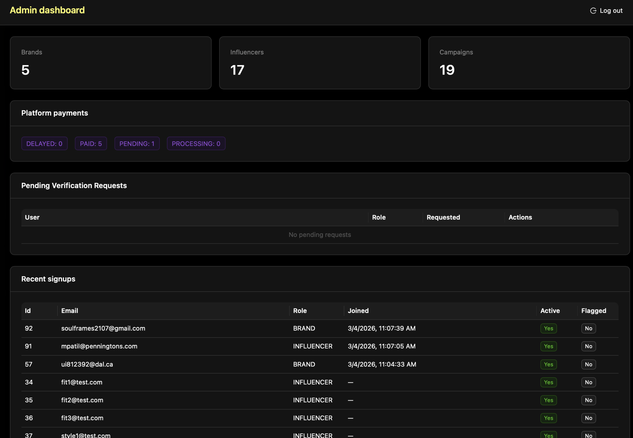
Logged in as admin@collabry.com, the platform engineer is strictly routed to /admin/dashboard. The dashboard surfaces aggregated statistics showing total registered Brands versus total registered Influencers, alongside total campaign counts across all statuses. If a user behaves maliciously, the Admin utilizes the user management data tables to locate accounts by User ID and forcefully disable or remove their privileges, maintaining full platform integrity.

Scenario 4.2 — Admin Verification Review

Shot 16: The Verification Queue (/admin/dashboard — Verification Requests tab)

The Admin navigates to the “Verification Requests” tab on the admin dashboard. Clicking a pending request surfaces the user’s full profile details for manual review, including their website link and social media presence. The Admin then takes one of two actions: clicking the green checkmark instantly grants the user a Blue Checkmark on their public profile, while clicking the red cross rejects the request and prompts the Admin to supply a reason (e.g., “Link to social media is broken”). The rejected user sees this reason on their own dashboard and is permitted to re-apply after addressing the issue.
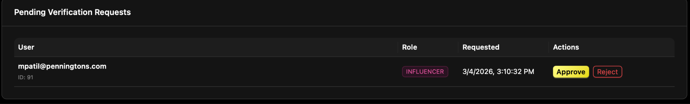

Scenario 4.3 — User Management (Safety First)

Shot 17: Flagging, Deactivation & Platform Safety (/admin/dashboard — User Management)
Upon noticing a report or suspicious activity, the Admin can Flag a user account, marking it for investigation while leaving the user active on the platform. If the violation is deemed severe, the Admin clicks “Deactivate”: the system simultaneously invalidates both the ACTIVE flag in the database and the user’s security token, instantly booting them from the platform and preventing any further access. This two-tier enforcement model ensures proportional and immediate responses to all levels of misconduct.
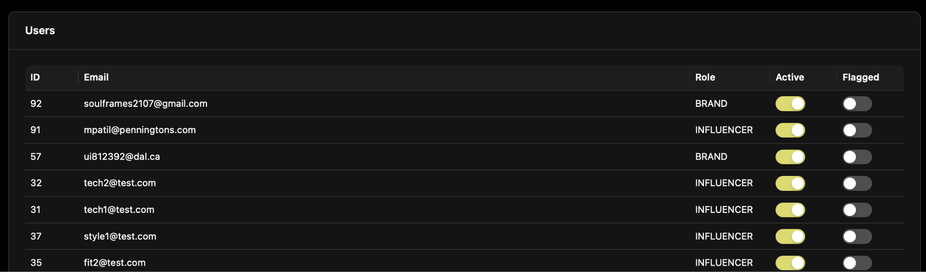
End of Collabry Usage Scenarios & Walkthrough Documentation

